Devansh Upadhyay

Roll No. 55, TYCSBS

Data Mining and Analysis

Practical No. 2

Dataset: iris.arff

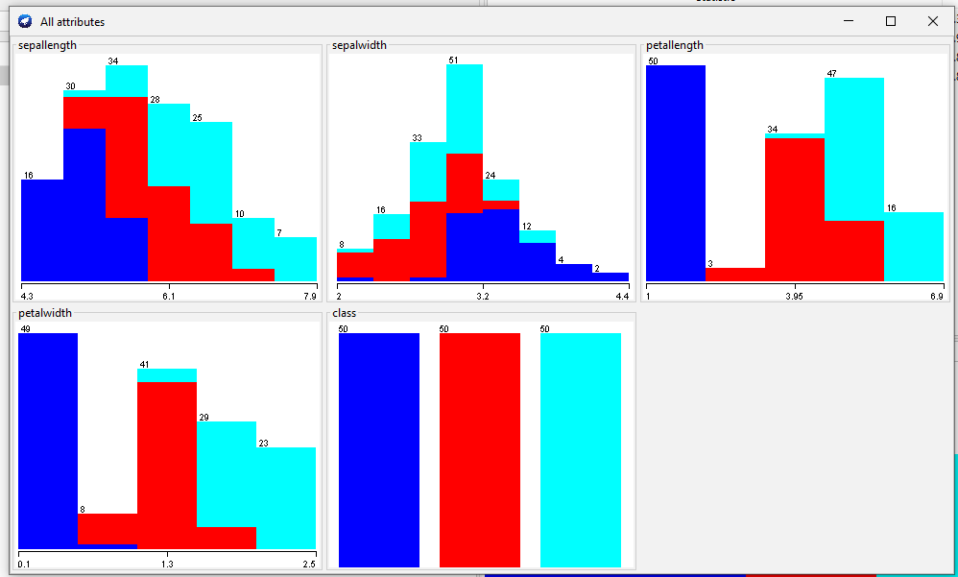

Here we visualized

